Lesson Title: Edible Soil Profiles
Subject: Science (4th grade)
Instructional Setting:
- Whole group instruction (beginning lesson)
  - sitting on floor in front of smart board.
  - Power point presentation
- Cooperative small groups (hands on activity)
  - Groups of 4-5
  - Seated at tables
Standards & Objectives: Utah 4th grade Science Standards
- 3.3a Observe & list the components of soil (minerals, rocks, air, water, living and dead organisms) and distinguish between the living, nonliving and once living components.
- 3.3b Diagram or model a soil profile showing topsoil, subsoil, and bedrock and how they differ in composition
Lesson Objectives:
- At the conclusion of the Power point presentation, the students will demonstrate their ability to identify and analyze the three soil profile layers by observing photos of the different layers with at least 83% accuracy (5/6).
- During the instructional period, the students will complete the accompanying graphic organizer outlining the different layers of the soil profile and listing key components of each with 100% accuracy.
- After viewing the power point presentation, the students will synthesize a model of a soil profile using edibles to show topsoil, subsoil and bedrock and how they differ in composition with 100% accuracy.
Language Objectives:
- During the instructional period, students will define the following key academic terms in their graphic organizer: soil profile, topsoil, subsoil, bedrock, organism, nonliving soil components, and nutrients.
- During the instructional period, the students will use various methods to aquire these new key academic vocabulary words.
  - Repeat orally
  - Hand actions
  - Rhythms
  - Writing word and definition
  - Make connections
- After completing the hands on activity, students will play the game Clue 3-2-1 (Indicio 3-2-1) in a small group setting to reinforce and self-assess mastery of the newly developed vocabulary.
Materials and Resources:
- Picture of layered cake
- “Soil Profiles” Power Point Presentation- computer, smartboard, and projector
- Plickers card for each student
- Cell phone with Plickers app
- “Soil Profiles” Clue 3-2-1 game
- “Soil Profiles” graphic organizer
- Edible Soil Profile hands on activity- 6 oz. clear plastic cups (one for each student), Ziploc baggies- sandwich size, bedrock=m&m’s, Reeses Pieces, Werthers, or other hard candy; subsoil=finely crushed and not coarsely crushed graham crackers; topsoil= crushed oreos (nutrient rich soil), gummy worms, gummy insects, green coconut (grass), green licorice (plants), spoons to scoop out ingredients and to eat with!
- Computers for students to complete Exit Ticket questions
Sources:
Utah State Office of Education. 2014. Grade 4 Science 2015-2016. Pgs. 50-52. Retrieved from:
schools.utah.gov/CURR/science/OER.aspx. July 6, 2016.
BING search engine for photos- each photo has source embedded into it.
Power Point Presentation, Graphic Organizer, Clue 3-2-1, Edible Soil Profile activity: My own creations
Instructional Plan:
Prerequisite Skills:
- Students must know what soil, rocks and minerals are.
- These were covered in the last unit, so we will check for understanding of these in the quick review and the induction activity.
Review: (2-3 min.)
- Quick review of material learned about day before. Whole group.
Induction/Attention: (5 min.) Whole Group
- Show students picture of layered cake. Ask what they notice about it. Key terms looking for: different layers, sections, different ingredients/textures, etc.
- Connect it with the Soil Profile.
Instruction: (20 min.) Whole Group
- Pass out graphic organizers and instruct students to fill it out as they learn about the Soil Profile.
- Show “Soil Profile” Power Point presentation (USS [Utah Science Standard] 3.3a
  - As new academic vocabulary words appear, help students learn them through the various strategies listed above.
- Assessment: “Soil Profile Quiz” at end of presentation using Plickers cards. Show results on smartboard.
Hands-on Activity (20 min.) to be done in small cooperative groups. USS 3.3.b
- Go over instructions to students about activity/ write directions on board as discuss:
  - FIRST, examine baggies #1, 2, 3. Which soil layer does your group think each is? Why? Prompt them to use their graphic organizer for help. CHECK with Mrs. Thacker before going on to step 2 .
  - SECOND, each student gets to measure the number of scoops or candies WRITTEN on the baggy into their cup.
  - THIRD, as a group identify what the contents of baggies #4, 5, 6, and 7 would
represent in the soil profile. Place them in the appropriate layer of your soil profile.
- While they are EATING their soil profiles, they are to play CLUE 3-2-1.
  - Model how this game is to be played with the help of 2 students.
- Instruct students to go to their tables. Have each materials specialist come get Ziploc baggies with premeasured layer ingredients inside; spoons; and cups.
- Monitor progress of activity.
Debrief/Review ( 10 min.)
- Think-Pair-Share- 5 min.
  - Begin with remembering questions and build upon to more thought provoking ones. “What are the three layers of the soil profile?” “Can you tell me a characteristic of _____________?” “What did this look like in your edible soil profile?” “Why do you think……?” Allow all students to process their response before calling on any student. Redirect the questions and allow at least 3 different students to respond to each question.
- Exit Ticket- 5 min.
  - In our Google Classroom, respond to the following questions: 1) On a scale from 1-5, how well do you think you know the material we covered in class today? 2) Do you have any questions? Or, is there something you are still unsure about? 3) What did you enjoy about our lesson today? 4) What would you change about our lesson today?
Instructional Strategies:
Whole group discussion, Questioning: redirecting, probing, hands-on-activity, Small group game, Technology: Power Point presentation, Plickers, Google Classroom exit ticket.

3 Different Active Participation Strategies:
Cooperative group (4-5) for hands on activity, Vocabulary building strategies: repeat, rhythm, connections, hand actions (during PP presentation), Clue 3-2-1 game; Think-Pair-Share during review time: called on several different students and used redirecting.

1 Grouping Strategy:
Small cooperative groups (4-5) for hands-on activity and game, Whole group instruction (PP presentation, Induction, review), Independent (exit ticket).
1 Formative Assessment Strategy:
Small groups had to check with me to assess whether they had correctly identified the edible layers and components before they could assemble their models.

Use of Technology:
Power Point Presentation
2 Student-Centered strategies:
Plickers cards and app (formative assessment during PP presentation), Exit ticket assignment on Google Classroom (formative assessment)
Differentiated Instruction Accommodations:
1. Students below grade level: We completed graphic organizer as a group. I gave clear descriptions so students could understand key differences in the soil layers and components.
2. Students above grade level: I asked the groups to apply what they had learned about the soil profile layers to identify the edible layers/components and to explain why those ingredients should be identified as such. I asked higher-order thinking questions during our Think-Pair-Share so that they could be challenged to think more. I also asked them open ended questions on the Exit Ticket.
3. Students with ADHD: This lesson used a variety of strategies, which helps keep the attention of students who have a hard time focusing. I used several active participation strategies that help these types of students, ie: Plickers, hands-on activity, Clue 3-2-1 game, different ways to respond for assessments: exit ticket, think-pair-share.
4. Students who are ELLs: I incorporated several vocabulary strategies to help them aquire the key academic terms for this unit. The game Clue 3-2-1 also served as a review for these students. At the beginning of the lesson, I used a visual of a layered cake and helped the students make connections throughout the lesson about the soil profile. The graphic organizer also clearly shows this layer effect.

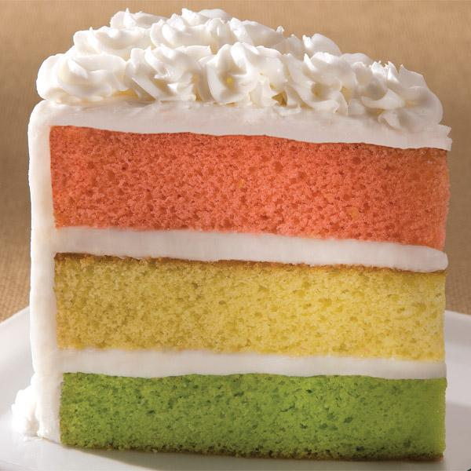
Source: http://www.recipeshubs.com/layer-cake/27733

