THE SNOWY DAY
A B

B A

A A B B

B B A

©Dari Thacker 2014
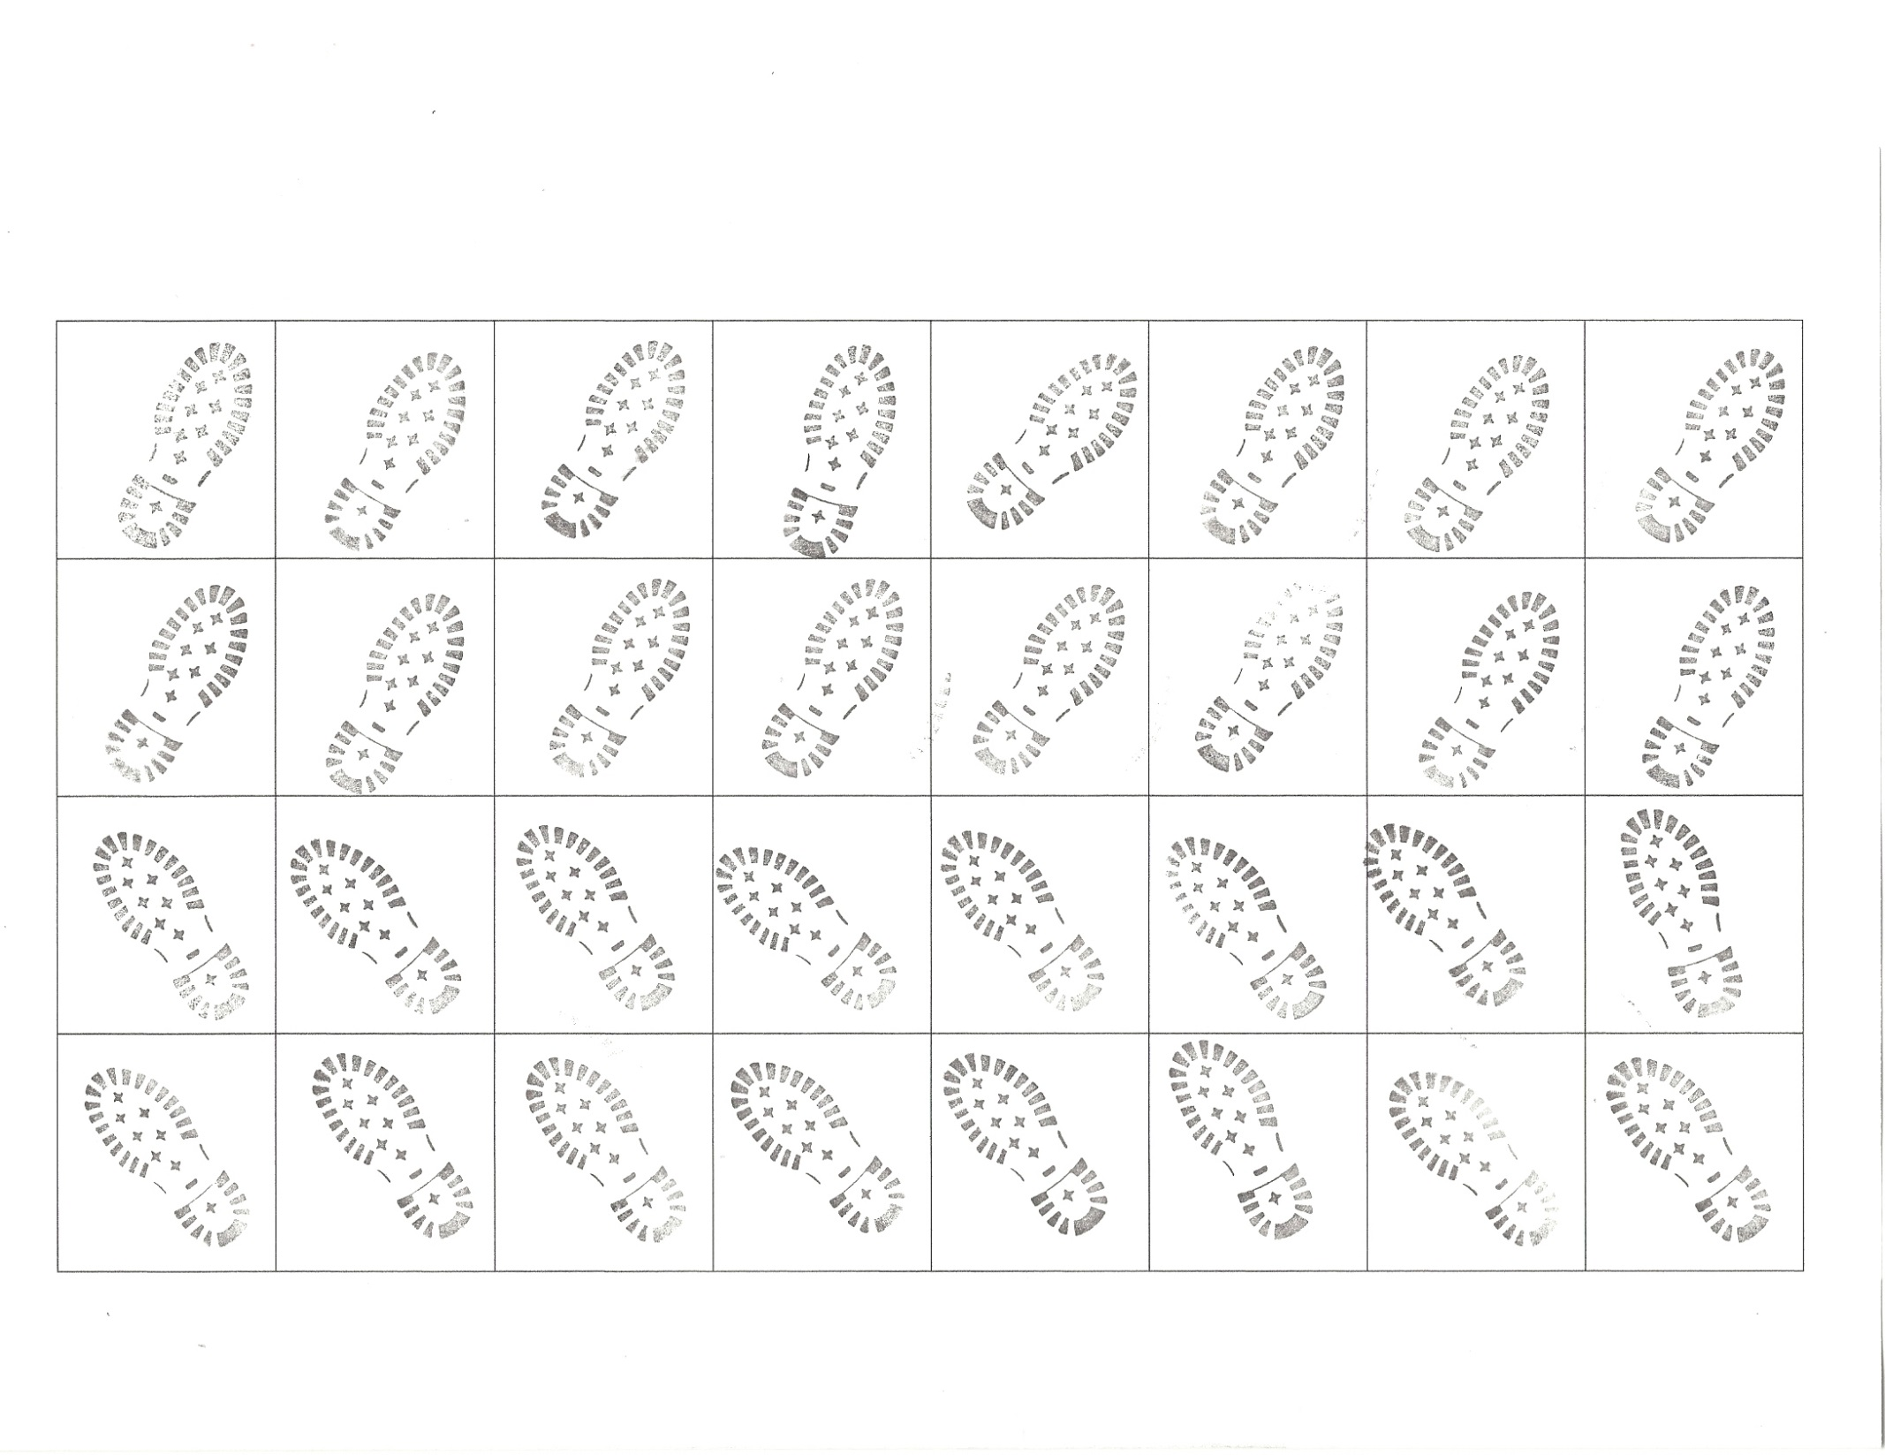
Have children cut out squares along lines. Use these footprints for the Pattern Page and also for The Snowy Day mat. Tip: It will probably be easier for them if you tell them to cut them into strips and then cut the smaller lines to create the individual squares. I recommend that you print this out on cardstock.
Footprint stamp from Stampin Up!

© Dari Thacker 2014
1 1 2 2 3 3 4
4 5 5 6 6 7 7
8 8 9 9 0 10

© Dari Thacker 2014. Cut these into squares and use them on The Snowy Day mat to count out corresponding amount of footprints or to use as an adding board. I would recommend printing this page out on cardstock. You may even want to laminate the cards.

